Quranic Verses

Surah Al-Anbya (ayat-22):

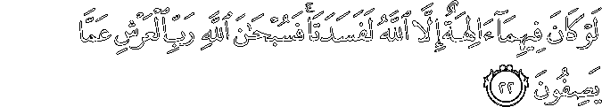
Had there been within the heavens and earth gods besides Allah, they both would have been ruined. So exalted is Allah, Lord of the Throne, above what they describe.

Surah al-Baqarah (ayat-163):
:
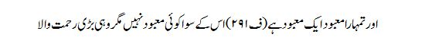
And your God is one God, there is no God but He most Gracious and Merciful.

Surah al-Baqarah (ayat-164):

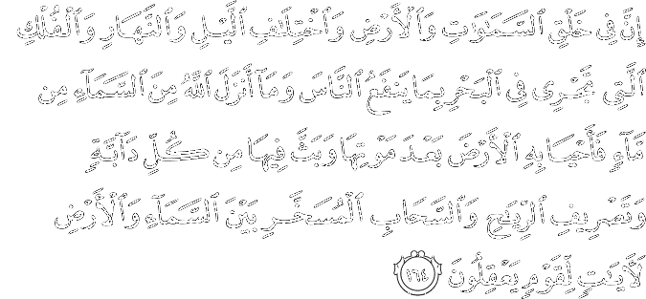
Indeed, in the creation of the heavens and earth, and the alternation of the night and the day, and the [great] ships which sail through the sea with that which benefits people, and what Allah has sent down from the heavens of rain, giving life thereby to the earth after its lifelessness and dispersing therein every [kind of] moving creature, and [His] directing of the winds and the clouds controlled between the heaven and the earth are signs for a people who use reason.
Surat Al-Furqan (ayat-60):
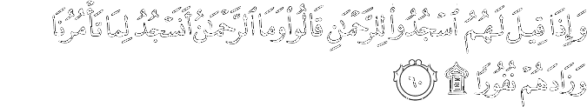
And when it is said to them, "Prostrate to the Most Merciful," they say, "And what is the Most Merciful? Should we prostrate to that which you order us?" And it increases them in aversion.

Surat Al-Furqan (ayat-63): 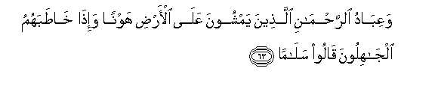

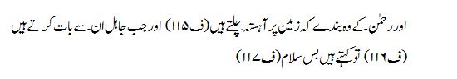
And the bondmen of the Most Affectionate are those who walk on the earth modestly and when the ignorant address them, they say, 'peace'.

Surat Al-Furqan (ayat-77):
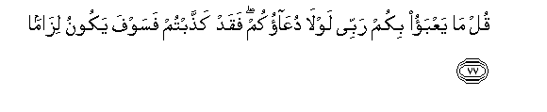
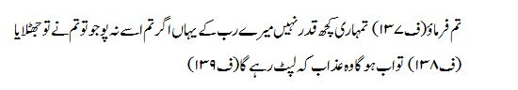

Say you, 'you are of no value to my Lord, if you do not worship Him; then indeed; you belied, therefore now there will be a cleaving torment.

Say, "What would my Lord care for you if not for your supplication?" For you [disbelievers] have denied, so your denial is going to be adherent.

Surat Al-Imran (ayat-79):
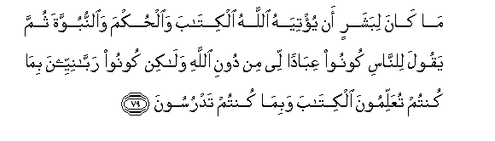
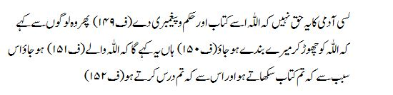
It is not the right of any man that Allah should give him the Book and command and prophet hood, then he should say to people, 'Be my bondmen leaving Allah; Yes he will say this, 'Be men of Allah because you teach the Book and because you study it.

Surat Al-hashar (ayat-7):
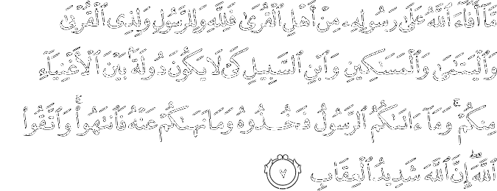
And what Allah restored to His Messenger from the people of the towns - it is for Allah and for the] Messenger and for [his] near relatives and orphans and the [stranded] traveler - so that it will not be a perpetual distribution among the rich from among you. And whatever the Messenger has given you - take; and what he has forbidden you - refrain from. And fear Allah ; indeed, Allah is severe in penalty.

